29.58: a) According to Example 29.6 the induced emf is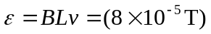 Note that is the size of the bar measured in a direction that is perpendicular to both the magnetic field and the velocity of the bar. Since a positive charge moving to the east would be deflected upward, the top of the bullet will be at a higher potential.
b) For a bullet that travels south, the induced emf is zero.
c) In the direction parallel to the velocity the induced emf is zero.

